Passport

Photo

(Jpeg)

***Application Deadline: May 2nd, 2022***

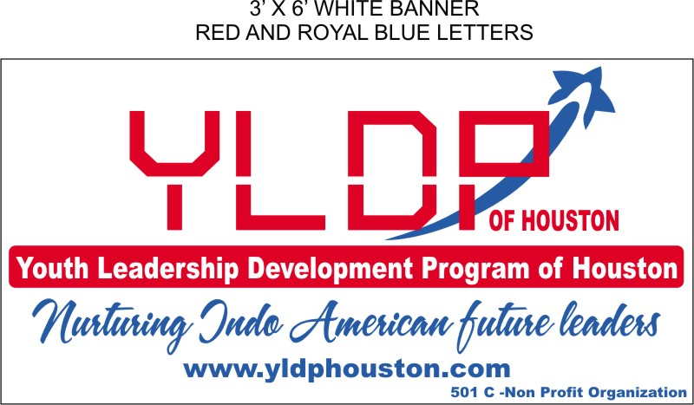

**Youth Leadership Development Program of Houston**

**Class of 2023**

**Name of the Student:**  **Gender: □ Male □ Female □**

**Home Address:**

**School Name**:  **Grade (Junior/Senior) in 2022-2023**

**Student Phone:**   **Student E-mail**

**Mother’s Name:**   **Phone (cell)**   **E-mail**

**Father’s Name: Phone (cell)**   **E-mail**

**(Note: All correspondence will be via email to the Student’s Email ID)**

**How did you hear about YLDP?**

**What do you know about YLDP?**

**Leadership positions held (School/External):**

**Interests:**

**Hobbies:**

**Art & Culture:**

**Sports:**

**Community Service activities:**

**Passion in life:**

**I aspire to become**

**Why are you interested in joining YLDP? (Write in 100 words) - use separate sheet if needed**

**How do you foresee your role as a future leader? (Write in 100 words) - use separate sheet if needed**

**Parents interested in volunteering for YLDP □ Yes □ No □ Maybe**

**Instructions *(Application Deadline for Class of 2023: May 2nd, 2022)***

1. Type and send application as an email attachment to [admissions@yldphouston.org](mailto:admissions@yldphouston.org) as a Word or PDF document.
2. Contact Selection Director, or any BOD for any questions at <http://yldphouston.org/directors.html>.
3. **Program annual dues of $ 250 to be sent post selection**. ***Students can apply for financial assistance (need based), contact Chairman, YLDP, for details.***

I hereby agree with the program requirements and apply for the Youth Leadership Program of Houston (YLDP)

_______________________ (Student Signature) ______________________ (Parent Signature for a minor)